Freeboard-installer Notes

Clone Rob42's freeboard-installer.

Open project in NetBeans.

I
n order to compile, had to add maven plugin:

<plugin>
<groupId>org.apache.maven.plugins</groupId>
<artifactId>maven-compiler-plugin</artifactId>
<version>2.3.2</version>
<configuration>
<source>1.7</source>
<target>1.7</target>
</configuration>
</plugin>
</plugins>

Clone Rob42s maptools.

Open project in NetBeans

To enable compile, had to comment out:

//import org.junit.After;
//import org.junit.Before;
//import org.junit.Test;

Then it compiles.

Back to freeboard-server project. In Project Tad, go to Dependencies and Right-Click → Add Dependency

Fill in the info for maptools:

Then manually install local jar.

9/15/2015
A test of the Chart Install proceedure was run on Region 5 NOAA charts. Of 194 charts, there wsere 68 failures. There is a list of the failures in CharetInstallFailures.txt.

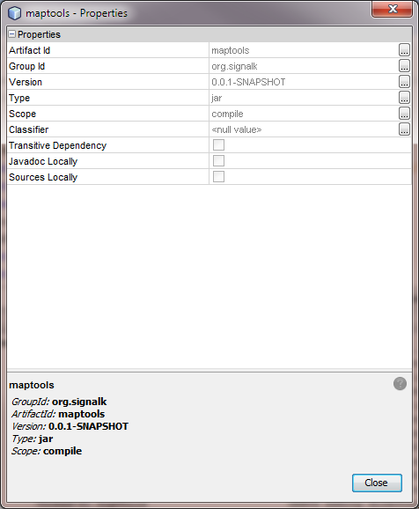

Freeboard-installer now works.

Copied in InstallManager.java from http://GitGub.com/RBerliner/freeboard-multi-installer

Merged with Rob42s code.

Now works.

